Quick Business Owner Guide To Youtube Marketing

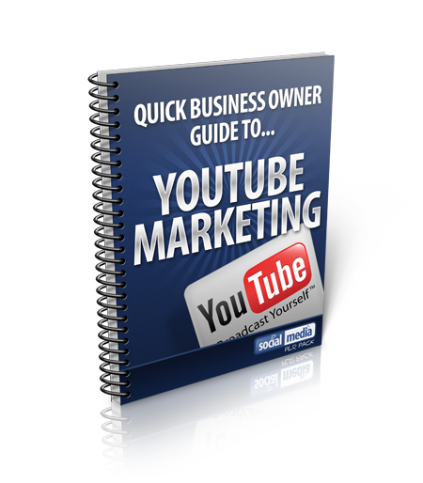

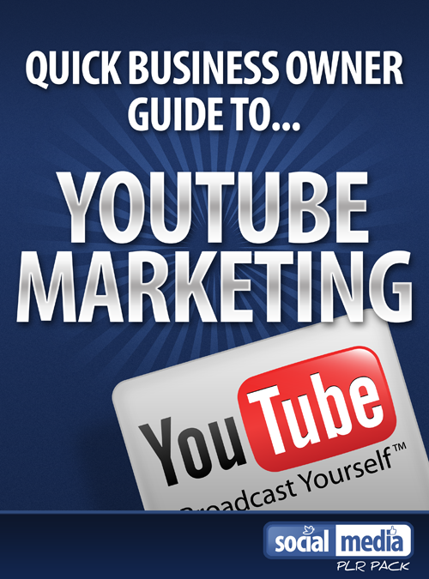

YOUTUBE FOR BUSINESS
Youtube is the world’s most popular video sharing site, where nearly four billion videos are viewed on it each day.
Businesses can tap into this massive market by following certain steps that can lead to increased visibility of their business, brand or product and in turn could lead to more customers and increased profits.
In this Youtube for business guide, I will show you what you need to do in order to get your message across onto Youtube.

HOW TO MAKE A YOUTUBE VIDEO
The image quality of your videos is vital. Low resolution videos may give you the sense that your product, company or service are amateurs, so is it important that when making your video you try to ensure that your video is of a high quality.
One option to achieve this could be to hire a professional video maker. For medium or large sized businesses, this could be an option, if they can afford the probable $600 budget. But for smaller sized businesses, this could be an issue.
Instead, you could buy a simple and cheap video camera, such as this Kodak play sport.
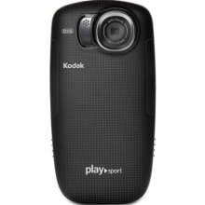
Which is HD compatible and retails on the Internet at $66. Or you could use your Iphone 4s, or a webcam.

Cameras such as this will provide excellent quality video, for an affordable price.
Once you created your video you can use free editing software such as windows movie maker, which comes free with windows live movie maker which comes free with windows 7 and Apple’s imovie, which comes pre-installed with apple’s iLife software

How Youtube Can Help Your Business
There are dozens of different methods you can use when it comes to marketing your brand, company or product on Youtube.
Brand awareness is the main objective of some companies when they make Youtube videos. Others use YouTube to promote a specific product or item or use Youtube to try to increase visitors to the website or retail stores.
Other companies use Youtube videos for product training or even recruiting new staff for their business. The possible uses of Youtube videos are endless.

Raising Your Brand Profile on You Tube
A good example of a company using Youtube to raise the profile of its brand is old spice.
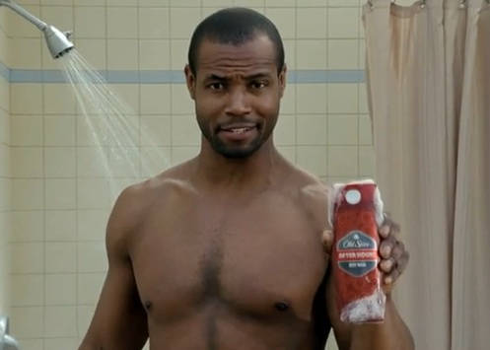
Who created the” the man your man could smell like videos.”
The videos were funny and clever and were views by millions on you tube and led to a spike in old spice sales.

Youtube Retail Promotion
Youtube can be used by retail stores, to promote services or promotions, such as “weekend sale extravaganza”
However a simple “weekend sale extravaganza” will not entice viewers to watch the video.
A more effective method to get more people to watch your videos would be to take viewers to a behind the scenes tour, showcase services you offer or create informative videos, that show views how they can for example, install bathroom equipment, or fix a leaking roof, using products from the retail store.

What Types Of Videos Can I Make?
Instructional Videos are how-to-do videos. In these types of videos, you show viewers how they can install a bathtub, like this video made by splashbaths.com


Product presentations and demos can be used to show viewers up-close how a particular product works and reveal the uses and benefits the product will give to its users.
Products that could be used well for product demos include, power tools, electronic equipment and computer gadgets and kitchen applications.


Real Estate Guides/walkthroughs can also make great Youtube videos.
Most realtors generally tend to use photographs to promote homes for sale or rent, but a video tour can add more detail to a property that’s for sale and give potential viewers greater clarity as to the benefits of a property. 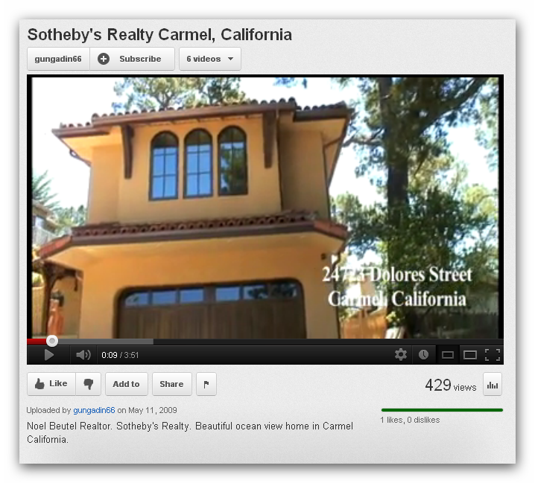
Customer testimonials can add authority to your companies brand and instil trust in new customers who have never heard of your brand or products before.
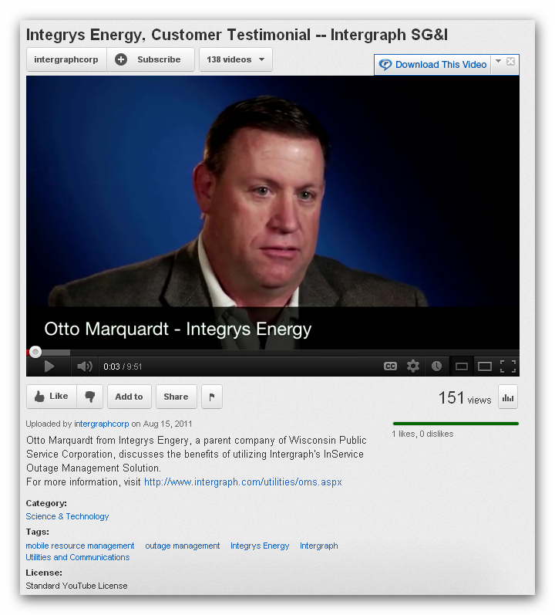
Video Blogs –The idea behind a video blog is that like a normal text based blog, you get an employee or yourself to talk about issues or news of the day, or make videos about a business trip you undertaken.


Creating Entertaining Videos
The most viewed videos on YouTube are the most entertaining videos.
And the most entertaining videos are the ones which combine humour with fun and these are the type of videos that are more likely to be shared through social media platforms and then go ‘viral.’
Some ideas for entertaining videos are, funny videos that contain stunts, which can be successful stunts or stunts that fail, or eating challenges, for instance, a chilli eating competition.
Other entertaining video ideas can be videos that shock or provoke viewers and humorous videos.
One company that has successfully tapped into making entertaining videos in Blendtec, whose “will it bend” videos are entertaining, provoking and funny, as company president Tom Dickson, dressed as a mad scientist, showcases the blendtec blender’s durability and strength by shoving various objects into the blender.
Some of the objects Dickson has blended include, the Iphone 4s, the kinect for Xbox 360 and the ipad2.
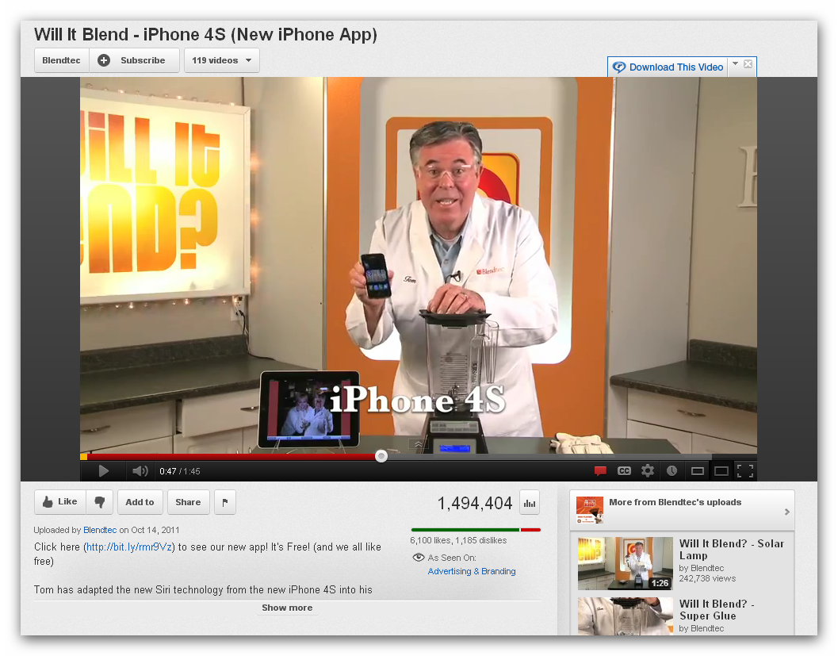
The effect of these videos is that they have spread like wildlife across the world wide web, by people intrigued, entertained and aghast at expensive, high value items being torn to shreds.
Each of the “will it blend” videos are produced on a budget of less than $100, which shows that businesses need not spend thousands on producing videos that will draw customers to their product, brand or services.
For a FREE consultation on Youtube marketing please call on xxx-xxx-xxx or send an email to myemail@domain.com

Your Name

