Quick Business Owner Guide To Pinterest

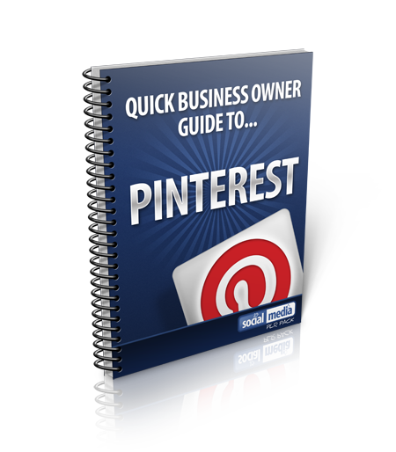

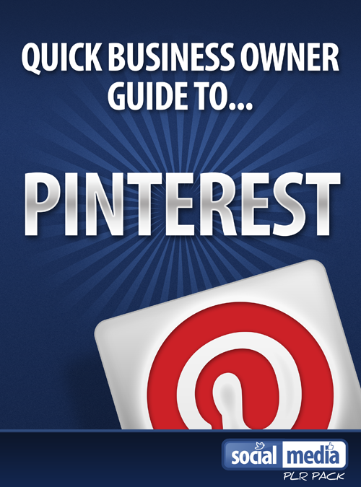

Copyright 2012

Introduction
Welcome to a special short guide on Pinterest.
Pinterest is the new social media website that is simply an online pin board where people are sharing all kinds of things. It lets you organise and share all the beautiful things you find on the web!
In this guide I am going to show you how you can create your own Pinterest board and start building a successful brand.
If you are a business owner then you need to get yourself on Pinterest because you are missing out on free social media traffic.
Are you ready to learn how you can use Pinterest for your business? Are you ready to discover the power of Pinterest in getting new customers through your door?
Please read on!

Pinterest Statistics
The first thing you should be aware of is that Pinterest provides more referral traffic to other sites than Google+, Youtube and LinkedIn Combined.
Pinterest users spend an average of 16 minutes on the site per visit.

50% of Pinterest users have children
Almost 70% of Pinterest users are female
97% of Pinterest’s Facebook fans are women!
28% of users are between the ages of 35-44
27% are between 25-34
The site has grown from 10 million total visits to 17 million since start of 2012.
Pinterest receives over 1 million visitors each day!
It is the 24th most popular website in the US
28.1% of users have an annual household income of $100k.
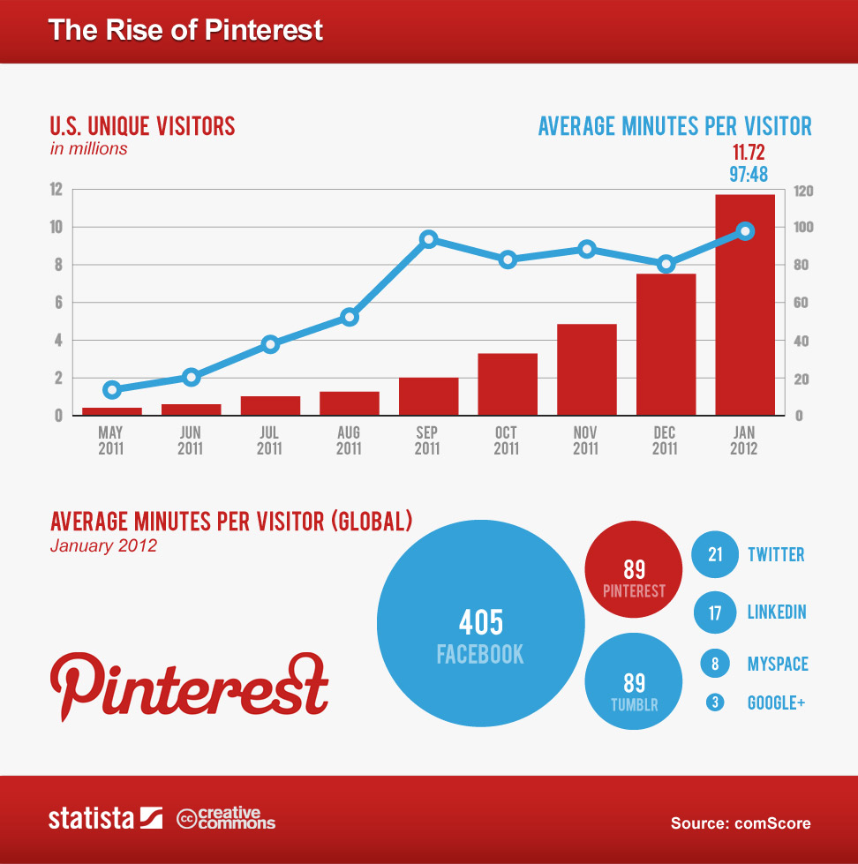

The sheer volume of these stats makes sense to brand your business on Pinterest. In the next section I am going to show you how you can get started.
Getting started on Pinterest
The first thing you see when you head over to www.Pinterest.com is that you cannot register. At this present moment in time the site is taking registrations by “invitation only” which means you have to email me for a Pinterest invite.
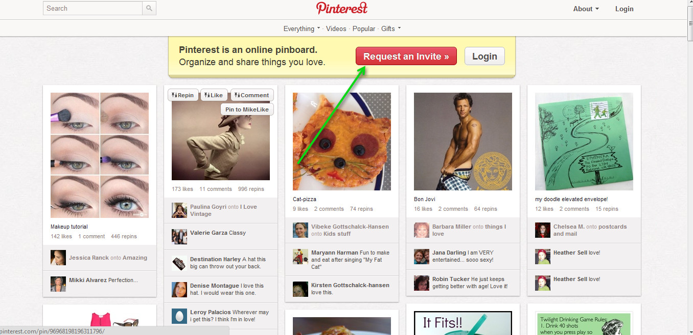

Once you have the invite you can register on Pinterest.
So how do you go about creating a Pinterest board?
It is pretty easy.

Creating a Pinterest board is easy.
Click on the “Add” button at the top.
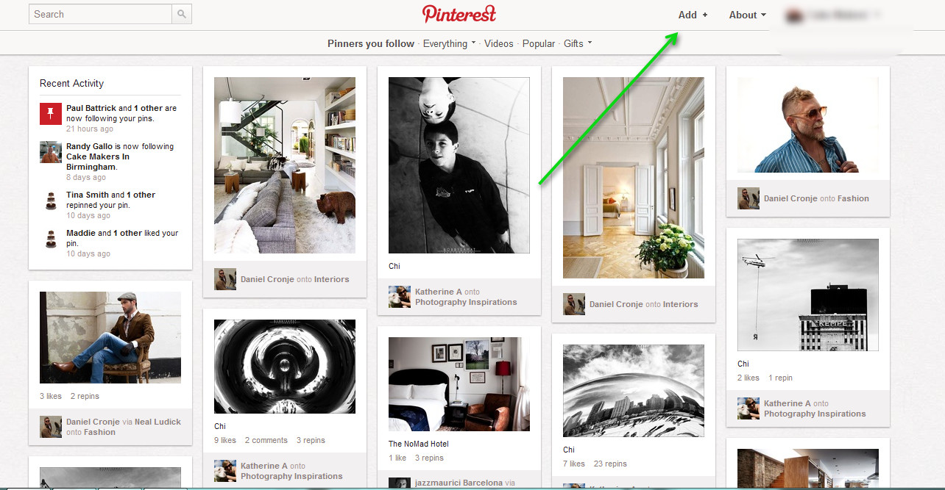

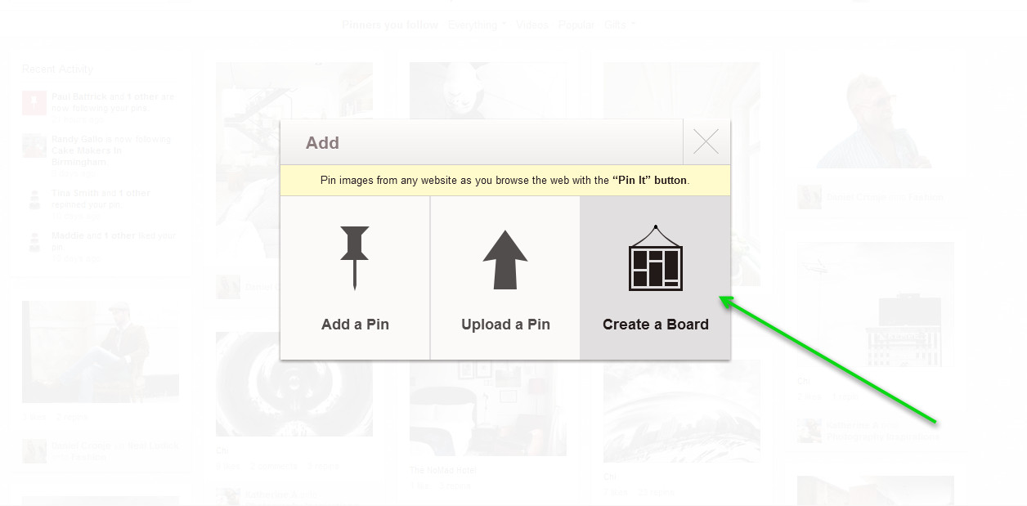

Then you simply need to click on “Create a Board”.
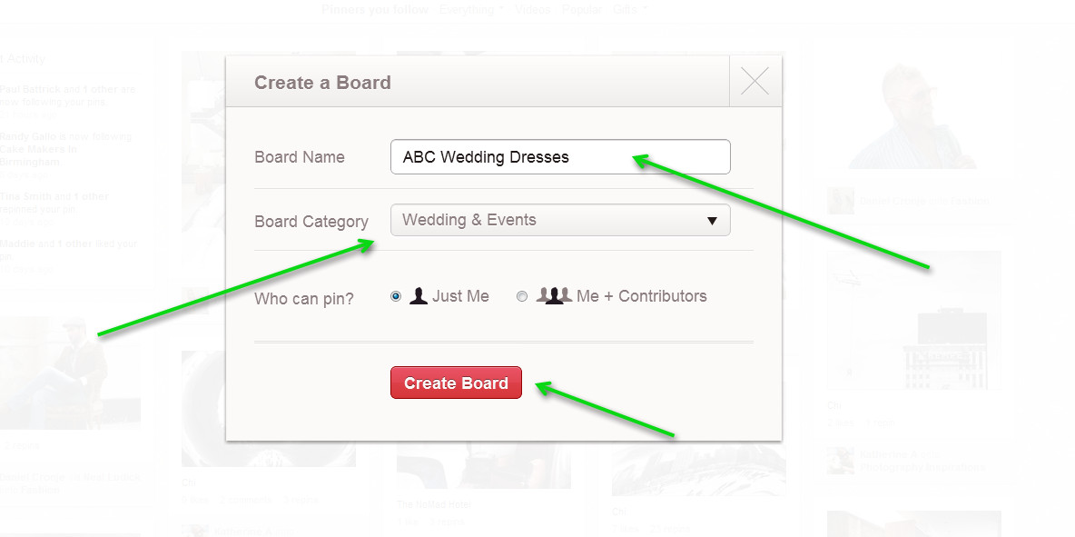

Then you need to fill out the information. Enter the name you want on your Board and choose a category.
Then click on “create board” once you are happy with the information.
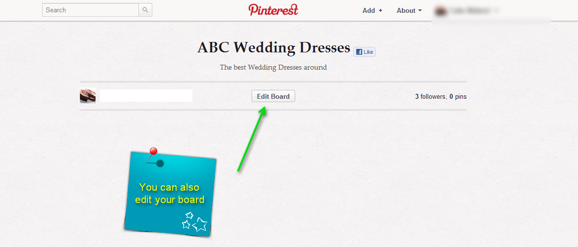

Feel free to choose an image for your Pinterest profile that relates to your business.
You can do this using the “settings” tab on Pinterest.
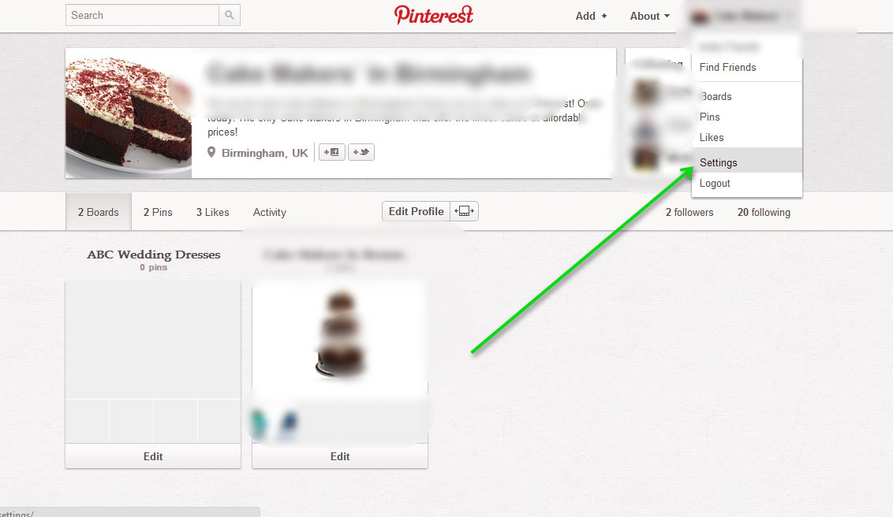

Adding a Pin
Is there something you want to share from your website?
You can also add a “Pin” from your website so it appears on your Pinterest board.
This is easy.
Go on your Pinterest board and then click on “Add”.
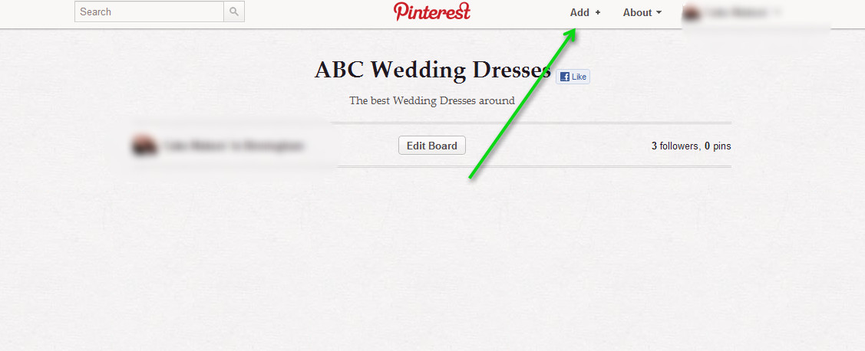

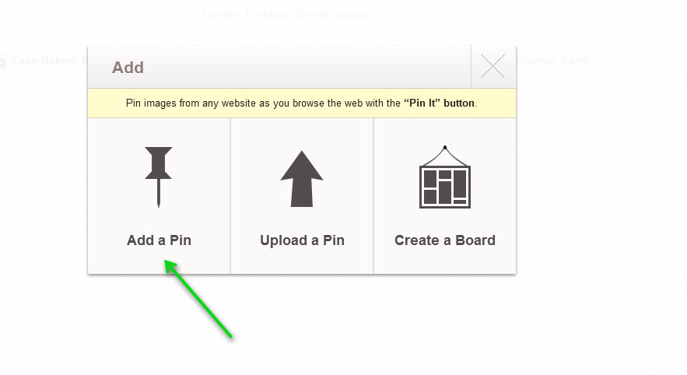

You then enter your website URL so it finds all the relevant images.

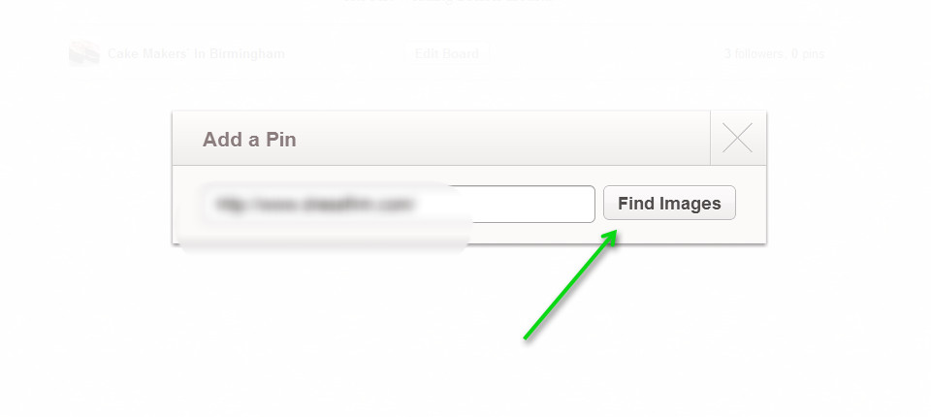

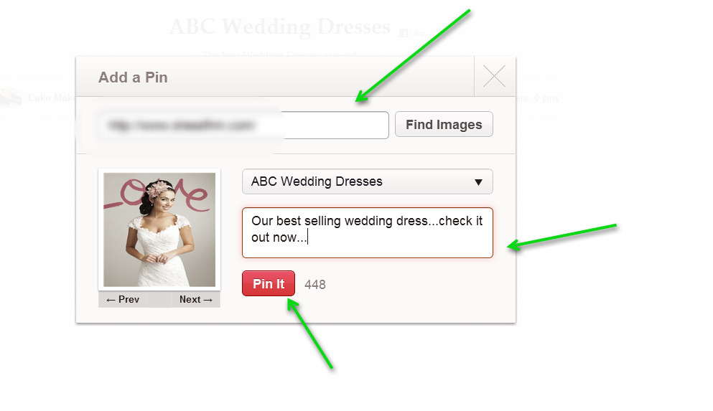

You should then see that you can select which images you want to pin from your website. Just enter a description and then click on “Pin It”.
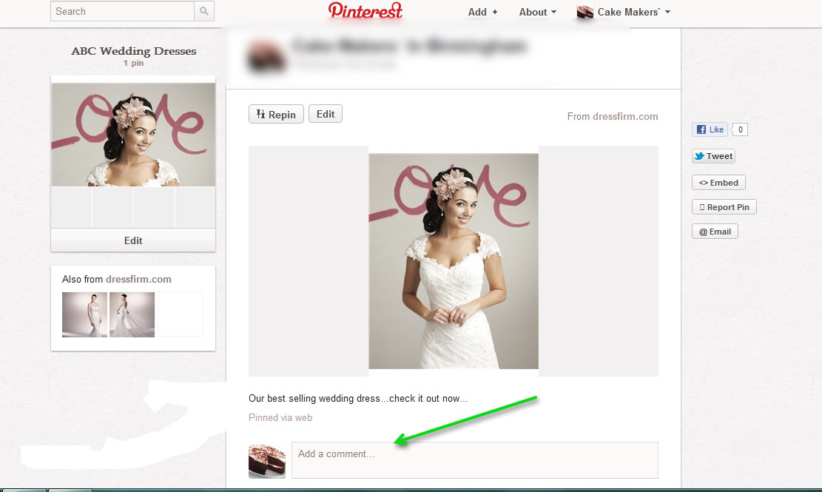

People can leave comments on your “Pin” once you have pinned something.
Your URL is also displayed if you pin something which means extra traffic for your website!
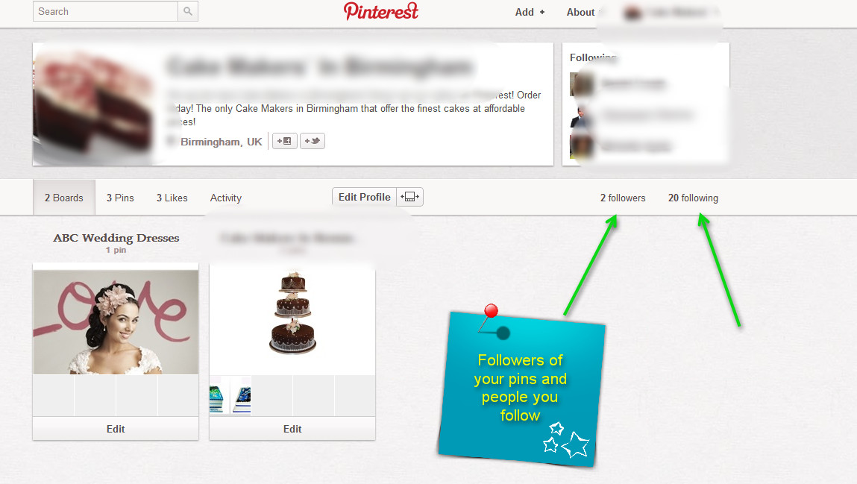

You can also get targeted followers on your Pinterest board. So this means that in future when you pin something on your Pinterest board these people will comment on your content and “repin” your content – i.e. pin your content on their board and get other people to pin your stuff.

If you want more information on how you can do this please contact me.

Pinterest is a great way to spread your brand and build buzz.
We can also integrate Pinterest on your Facebook page. This means each time someone visitors your Facebook page they will also visit your Pinterest board so they can see exactly what you have shared.
If you want a FREE consultation on Pinterest and want to find out more then please give us a call at xxx-xxx-xxx.

I look forward in hearing from you.

Your Name

