Quick Business Owner Guide To Facebook Marketing
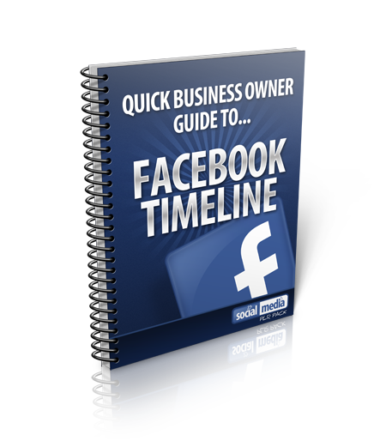

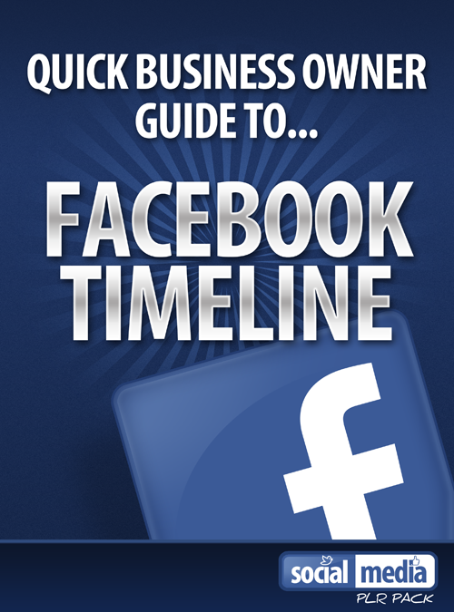

COPYRIGHT 2012

Your Name

Introduction
Welcome to a special short guide on Facebook marketing and how it can help your business.
Facebook has 800 million members and it has grown over the last 5 years. The rise of Facebook and its popularity has enabled many businesses to market their product and services on the world’s biggest social networking site.
In this guide I am going to show you why you should use Facebook and how it can benefit your business.
By the end of this guide you should have a good overview on Facebook. If you have any questions please do not hesitate to call me on xxx-xxx-xxx or send me an email to myemail@domain.com for a FREE consultation on Facebook marketing.

Some stats on Facebook
Here are some stats on Facebook.
Facebook has over 845 active monthly users.
Content on Facebook gets over 2.7 million likes everyday.
425 users are mobile users
There are an average of 43% males who use Facebook and 57% females.

The average time spent on Facebook is 20 minutes.
89% of agencies said they would use Facebook to advertise for their clients in 2012 – either by purchasing ads, creating pages, or other methods of engagement
Posts from Facebook pages with 10,000 fans reach 30 %to 40% of their fans, posts from pages with 100,000 fans reach 20% to 30% of their fans and posts from pages with 1,000,000 or more fans reach 10 percent of their fans
I am sure you agree that the above stats are pretty impressive.
Not bad for a site that started in 2004!
In the next section of this guide I am going to show you how to go about creating your own Facebook brand Timeline page.

Facebook Timeline Page
Many businesses who choose to market on Facebook are creating their own Facebook brand page.
If you don’t know what a Facebook page is then quite simply it is a page that allows business owners to share their content, upload photos, and connect with their audience. They can also use their page to advertise and gain new customers.
Want to know how to go about in creating one?
Just go to https://www.facebook.com/pages/create.php
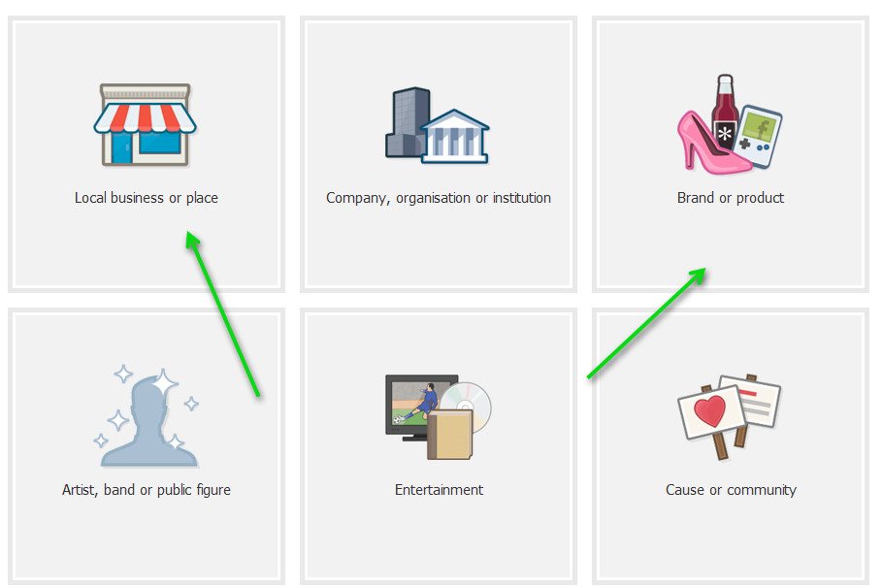

What you then need to do is click on the right category.
So for example, if you are a business owner then you will click “Local business or place”.
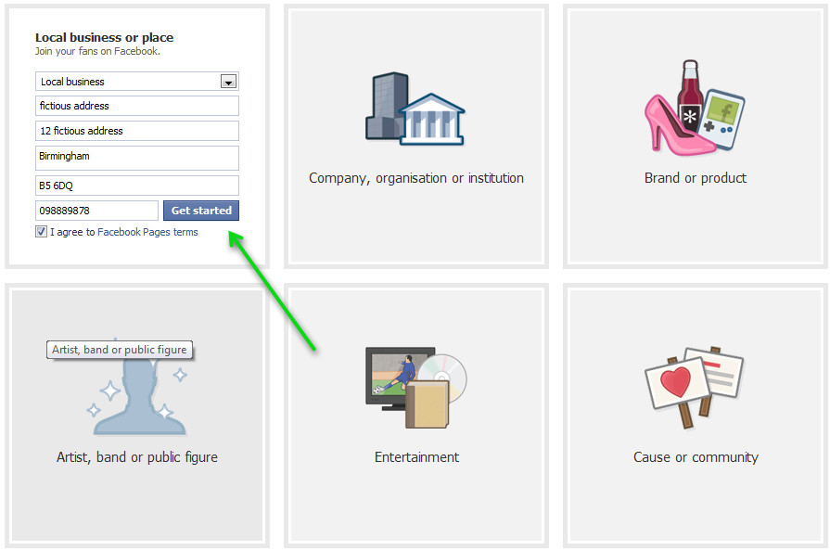

Fill out the information and then click on “Get started”.
Facebook will then give you a series of options to choose from.
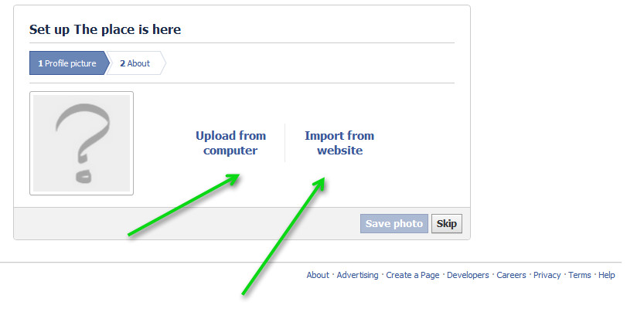
You can upload your company logo or profile picture here.
If you have a website you can choose to import images from your site.
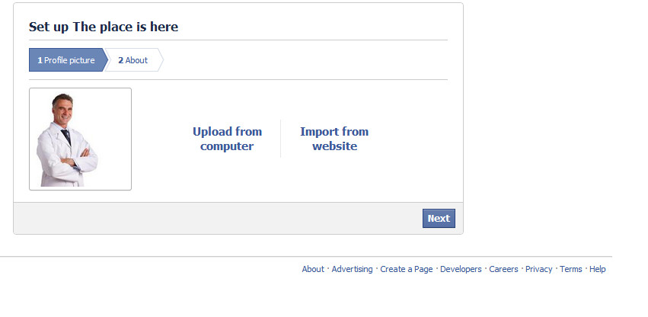

Then click “Next” once you have found an image you would like to use.
Enter a bit of information on your business.
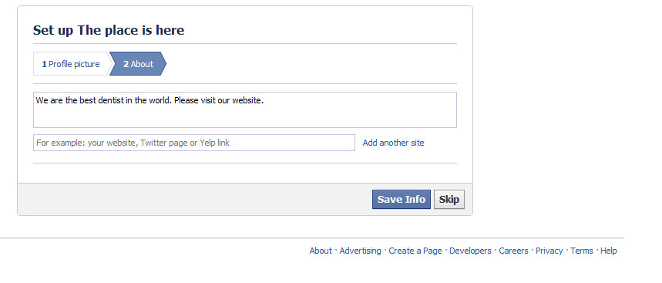

Click “Save Info” once this has been done.
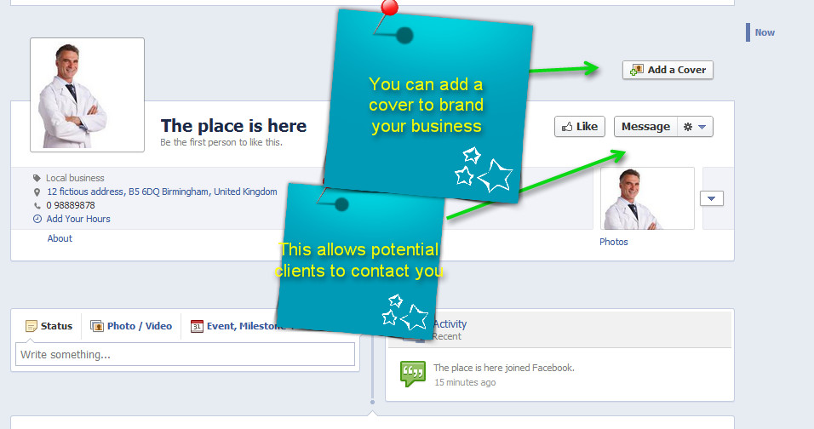

Your page should then be created. It only takes 5 minutes to create a Facebook page. Isn’t that easy?
Once your page is created you then need to optimise it –so you can engage your clients and get people to like your page.
The first thing you need to do is upload your own “cover” on Facebook.
Here are some examples of Facebook covers that have been created.
You should note that the cover runs horizontality across the Facebook page.

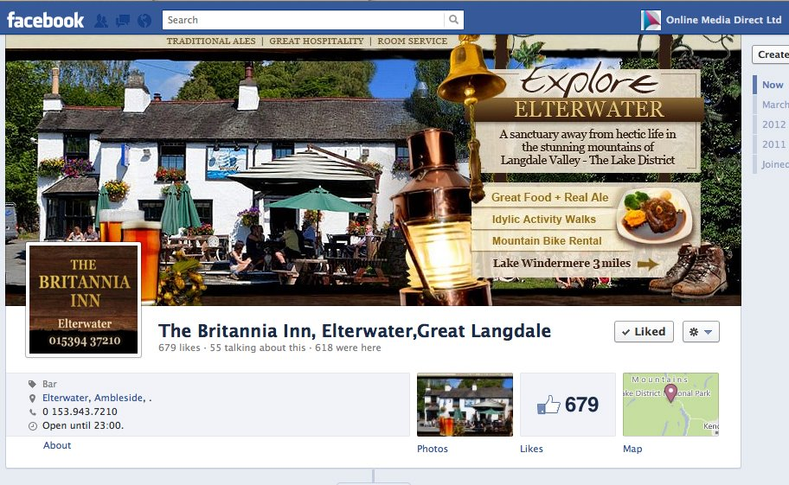

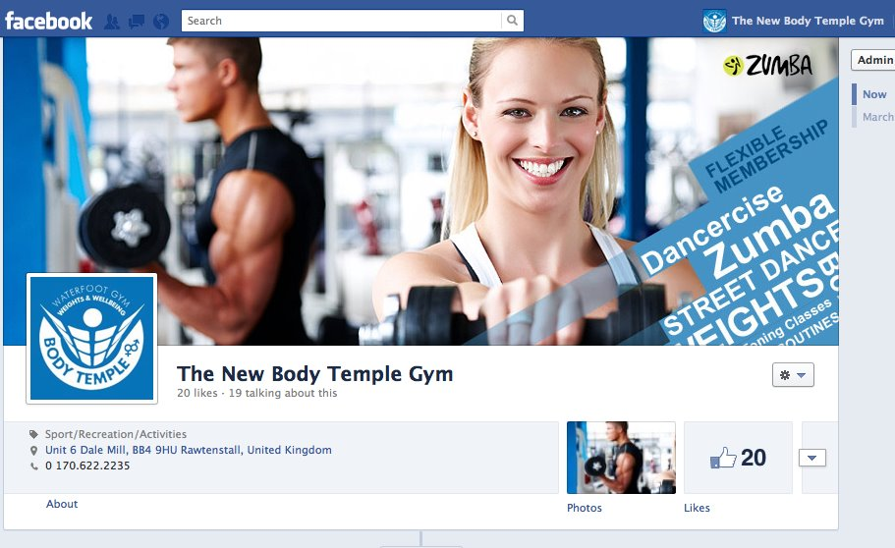

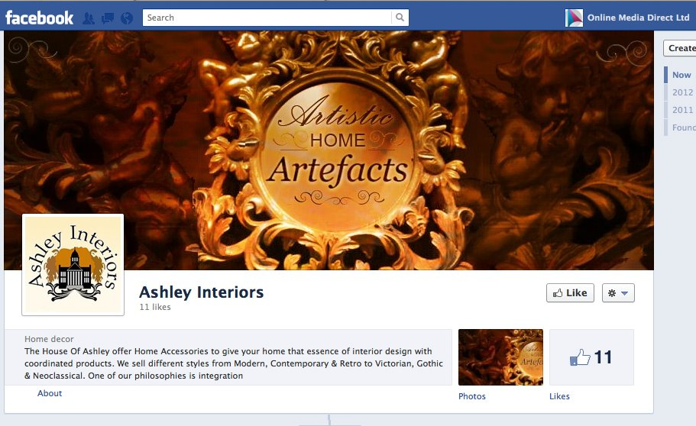

So how do you go about getting a great looking cover created for your business?
We can do that for an affordable price. All you need to do is contact us on the number at the end of this guide and we can create you a nice looking cover for your business.

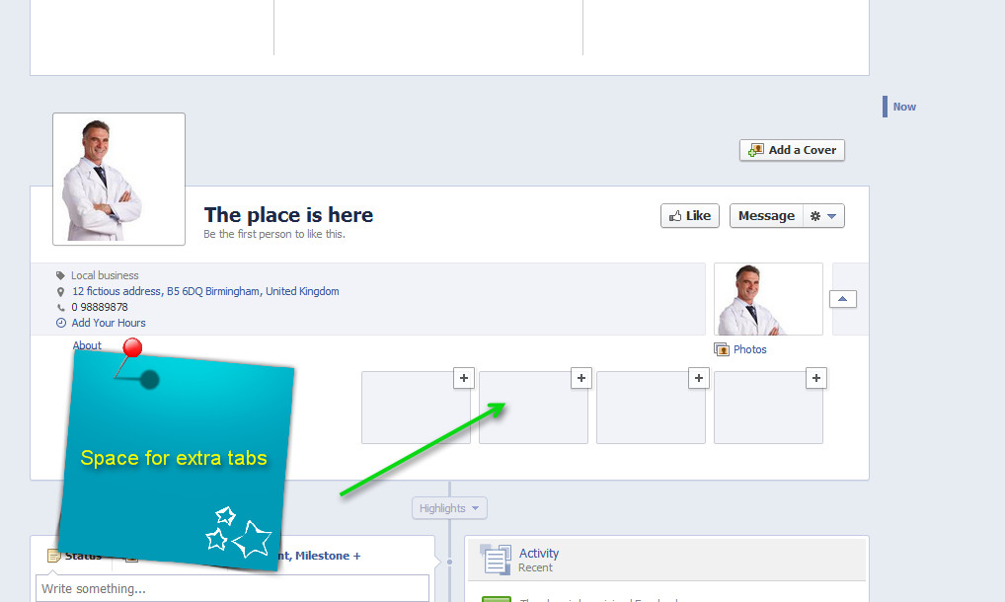

We can also add extra tabs for your page that will help people navigate your special offers etc.
We can integrate your website onto your Facebook page – which means people can browse your entire website without leaving Facebook!
We can also add a facility that will allow you to capture leads. This is important as this will allow you to keep in touch with existing and potential new customers.
Get more from your business with Facebook Ads
You can also advertise your business to millions and millions of potential customers on Facebook.
Here are businesses on Facebook advertising their products and services.
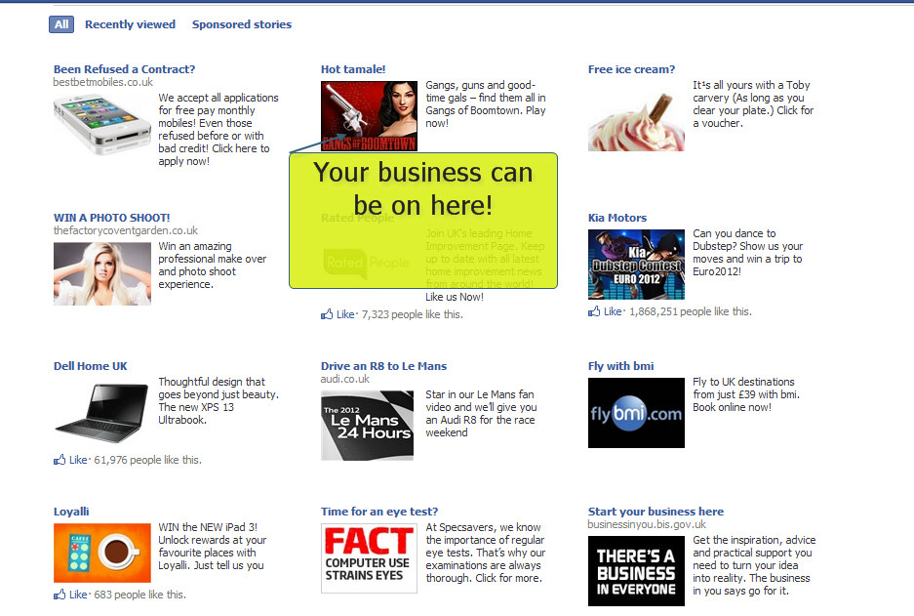

You can target your services to millions and millions of targeted customers. Do you want to jump on this bandwagon and get one step ahead of your competition?
Did you know by the end of 2011, Facebook’s ad revenue was 22 times larger than Twitter’s $139.5 million?
In 2011 Facebook served 175 billion ad impressions.
You can literally start advertising your business on Facebook today and increase your profits for your business.

We know you are a busy person so I am going to cut to the chase here.
For a FREE Facebook consultation please call xxx-xxx-xxx and I will walk you through your Facebook page (if you already have one).

If you don’t already have a Facebook page then I will guide you on the best strategy to take.
Please give me a call now at xxx-xxx for a FREE consultation or send me an email to email@domain.com

If your not marketing your business on Facebook then you are leaving a lot of profits on the table!

Your Name

